FREEDOM INTERNATIONAL SCHOOL
# 33, Sector IV, HSR Layout, Bengaluru, Karnataka 560102
SCHOOL CODE: 45175 AFFILIATION NUMBER: 830183

COMPUTER SCIENCE PROJECT
ON
Travel Planner
SUBMITTED BY
Arushi, Sunayana, Pavana
Class XI A

Under the guidance of
Ms. SUMITA TYAGI
PGT- COMPUTER SCIENCE

Vice Principal Principal
Ms. Clara David Ms. Sneha Rai
Freedom International School Freedom International School
Bangalore Bangalore



FREEDOM INTERNATIONAL SCHOOL
# 33, Sector IV, HSR Layout, Bengaluru, Karnataka 560102
SCHOOL CODE: 45175 AFFILIATION NUMBER:830183

CERTIFICATE

This is to certify that the Computer Science Project Report entitled
Project Name,
was carried out by Arushi, Sunayana, Pavana of Class XI,
Roll No. 13,48, , a student of
FREEDOM INTERNATIONAL SCHOOL in partial fulfilment of the Computer Science Practical Examinations prescribed by the CBSE
during the Academic Year 2023-2024.
I certify that this project has been done by him/her with his/her own effort with the guidance of the teacher.

Signature of the Teacher In-Charge Signature of the Principal
Ms. Sumita Tyagi Ms. Sneha Rai

Name of the Examiners Signature with date

- _______________________ __________________________

- _______________________ __________________________

ACKNOWLEDGEMENT

We would like to express our special thanks and gratitude to our teacher and project guide Ms. Sumita Tyagi who gave us the opportunity to work on this project. A lot of research was involved which helped us in learning more about the topic and discovering many new things. This has been an important learning experience.
Our sincere thanks to Ms. Sneha Rai, our principal, for her coordination in extending every possible support for the completion of this project.
We also thank my parents for their motivation and support.
Last but not least, we would like to thank all those who had helped directly or indirectly towards the completion of this project.

INDEX

Serial No. | Contents | Page No.
1. | Project Description | 5
2. | Requirements | 6
3. | Source code | 7-
4. | Output Screenshots | 25-
5. | Future Scope | 34
6. | References | 35

PROJECT DESCRIPTION

Our travel planner has been designed using tkinter. The user can input a month of their choice and the program generates a list of places suitable to visit in that season. The user then selects their choice of place and gets a brief description and list of hotels in that area. There is also a feature available to view the places on an interactive map.

PROJECT REQUIREMENTS

- Python
- Tkinter
- Tkinter mapview
- Pillow library

SOURCE CODE

Splash1:

import tkinter as tk
from PIL import ImageTk, Image

splash_window=tk.Tk()
splash_window.title('splash screeeeen!!')
splash_window.geometry('1400x800')
splash_window.configure(bg = 'black')
splash_window.overrideredirect(True) #to hide title bar
splash_label=tk.Label(splash_window,text='~welcome to....',
font = ('Times',40,'bold italic'),
bg = 'black',
fg = 'white')

test = ImageTk.PhotoImage(Image.open('yaatra.jpeg'))
labelimg = tk.Label(width=1000,
height=600,
image=test)
labelimg.place(relx=0.5,rely=0.5,anchor='center')

splash_label.pack(pady=20)

def main_window():
splash_window.destroy()
import page2

#timer
splash_window.after(3000, main_window)

splash_window.mainloop()

Maintrial:

import tkinter as tk
from PIL import ImageTk, Image

#in command prompt upgrade pip3 and install pillow

window = tk.Tk()
window.title('travel planner')
window.geometry('1400x800')
window.attributes('-fullscreen',True)
window.configure(bg = 'honeydew2')

def nextpage():
window.destroy()
import splash2

label1 = tk.Label(
text = '~Live your life by a compass not a clock~',
bg = 'honeydew2',
fg = 'gray40',
font = ('comic sans',20,'bold italic')
).place(relx=0.5,rely=0.2,anchor='center')

#inserting image

test1 = ImageTk.PhotoImage(Image.open('beach2.jpeg'))
labelimg1 = tk.Label(width=350,
height=180,
image=test1)
labelimg1.place(relx=0.02,rely=0.1,anchor='nw')

test2 = ImageTk.PhotoImage(Image.open('waterfall1.jpeg'))
labelimg2 = tk.Label(width=350,
height=180,
image=test2)
labelimg2.place(relx=0.95,rely=0.95,anchor='se')

test3 = ImageTk.PhotoImage(Image.open('mountain1.jpeg'))
labelimg3 = tk.Label(width=320,
height=165,
image=test3)
labelimg3.place(relx=0.95,rely=0.1,anchor='ne')

test4 = ImageTk.PhotoImage(Image.open('snow1.jpeg'))
labelimg4 = tk.Label(width=330,
height=200,
image=test4)
labelimg4.place(relx=0.02,rely=0.95,anchor='sw')

label = tk.Label(
text = 'Hello, my fellow traveller!\n\
Need help finding the perfect spot for your vacation?\n\
Simply enter a month of your choice and start planning your trip!',
borderwidth = 10,
bg = 'honeydew2',
fg = 'black',
font = ('Times',30,'bold italic'),
)
label.place(relx=0.5,rely=0.5,anchor='center')

label2 = tk.Label(
text = 'select month:',
bg = 'honeydew2',
fg = 'black',
font = ('Comic Sans',20),
)
label2.place(relx=0.5,rely=0.85,anchor='center')

text1 = tk.StringVar()
text1.set('choose here')
w = tk.OptionMenu(window,text1,
'January','February','March','April','May',\
'June','July','August','September','October',\
'November','December',
)
w.place(relx=0.5,rely=0.9,anchor='center')

button = tk.Button(
text = 'start planning!',
bg = 'white',
fg = 'black',
font = ('Times',20,'bold'),
command = nextpage,
).pack(side=tk.BOTTOM,pady=10)

window.mainloop()

Splash2:

import tkinter as tk
from tkinter import *
from PIL import ImageTk, Image
def nextpage():
window.destroy()
import page2

splash_root=Tk()
splash_root.title('splash screeeeen!!')
splash_root.geometry('1400x800')
splash_root.configure(bg = 'black')
splash_root.overrideredirect(True) #to hide title bar
splash_label=Label(splash_root,text='~following the compass~',
font = ('Times',40,'bold italic'),
bg = 'black',
fg = 'white')

splash_label.pack(pady=20)

test = ImageTk.PhotoImage(Image.open('compass.jpeg'))
labelimg = tk.Label(width=500,
height=500,
image=test)
labelimg.place(relx=0.5,rely=0.5,anchor='center')

def main_window():
splash_root.destroy()
import page2

#timer
splash_root.after(1000, main_window)

mainloop()

Page2:

import tkinter as tk
from tkinter import ttk
from maintrial import text1

window = tk.Tk()
window.title('travel planner')
window.geometry('1400x800')
window.configure(bg = 'honeydew2')
window.attributes('-fullscreen',True)

def prevpage():
window.destroy()
import maintrial

#def nextpage():
#window.destroy()

#months display
v1=text1.get()
if v1=='November' or v1=='December' or v1=='January':
label1 = tk.Label(
text = 'Winter months...',
bg = 'honeydew2',
fg = 'gray40',
font = ('comic sans',20,'bold italic')
).place(relx=0.5,rely=0.2,anchor='center')
label = tk.Label(
text = 'check out suitable places on the map',
borderwidth = 10,
bg = 'honeydew2',
fg = 'black',
font = ('Times',30,'bold italic'),
)
label.place(relx=0.5,rely=0.5,anchor='center')
def nextpage():
window.destroy()
import mapwinter

elif v1=='February' or v1=='March':
label1 = tk.Label(
text = 'Spring months...',
bg = 'honeydew2',
fg = 'gray40',
font = ('comic sans',20,'bold italic')
).place(relx=0.5,rely=0.2,anchor='center')
label = tk.Label(
text = 'check out suitable places on the map',
borderwidth = 10,
bg = 'honeydew2',
fg = 'black',
font = ('Times',30,'bold italic'),
)
label.place(relx=0.5,rely=0.5,anchor='center')
def nextpage():
window.destroy()
import mapspring

elif v1=='April' or v1=='May' or v1=='June':
label1 = tk.Label(
text = 'Summer months...',
bg = 'honeydew2',
fg = 'gray40',
font = ('comic sans',20,'bold italic')
).place(relx=0.5,rely=0.2,anchor='center')
label = tk.Label(
text = 'check out suitable places on the map',
borderwidth = 10,
bg = 'honeydew2',
fg = 'black',
font = ('Times',30,'bold italic'),
)
label.place(relx=0.5,rely=0.5,anchor='center')
def nextpage():
window.destroy()
import mapsummer

elif v1=='July' or v1=='August':
label1 = tk.Label(
text = 'Autumn months...',
bg = 'honeydew2',
fg = 'gray40',
font = ('comic sans',20,'bold italic')
).place(relx=0.5,rely=0.2,anchor='center')
label = tk.Label(
text = 'check out suitable places on the map',
borderwidth = 10,
bg = 'honeydew2',
fg = 'black',
font = ('Times',30,'bold italic'),
)
label.place(relx=0.5,rely=0.5,anchor='center')
def nextpage():
window.destroy()
import mapautumn

elif v1=='September' or v1=='October':
label1 = tk.Label(
text = 'Monsoon months...',
bg = 'honeydew2',
fg = 'gray40',
font = ('comic sans',20,'bold italic')
).place(relx=0.5,rely=0.2,anchor='center')
label = tk.Label(
text = 'check out suitable places on the map',
borderwidth = 10,
bg = 'honeydew2',
fg = 'black',
font = ('Times',30,'bold italic'),
)
label.place(relx=0.5,rely=0.5,anchor='center')
def nextpage():
window.destroy()
import mapmonsoon

button = tk.Button(
text = 'MAP',
bg = 'white',
fg = 'black',
font = ('Times',20,'bold'),
command = nextpage,
).pack(side=tk.BOTTOM,pady=10)

window.mainloop()

Mapwinter:

Mapspring:

Mapsummer:

Mapautumn:

Mapmonsoon:

OUTPUT SCREENSHOTS

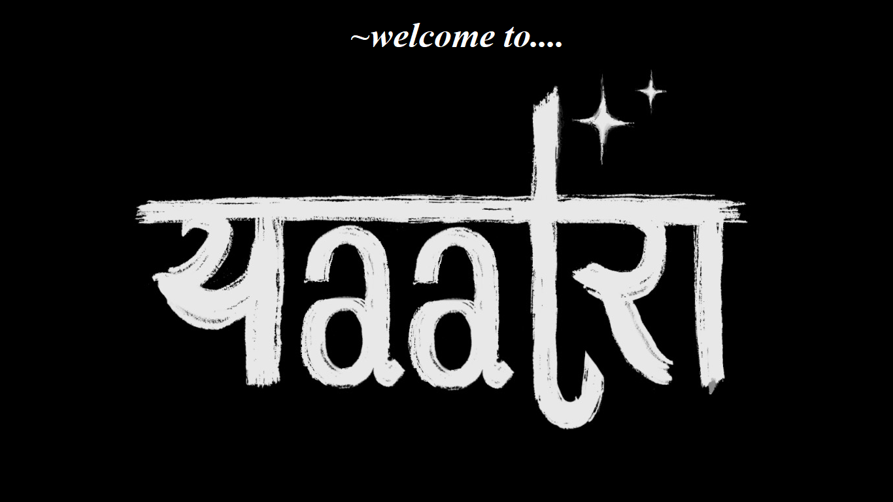

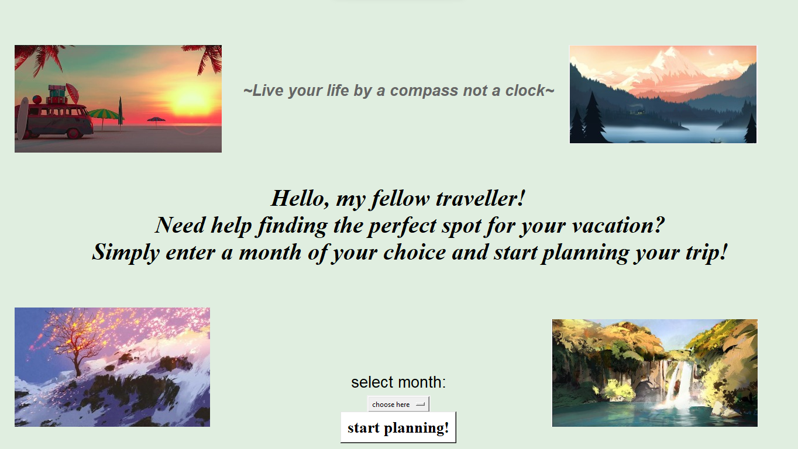

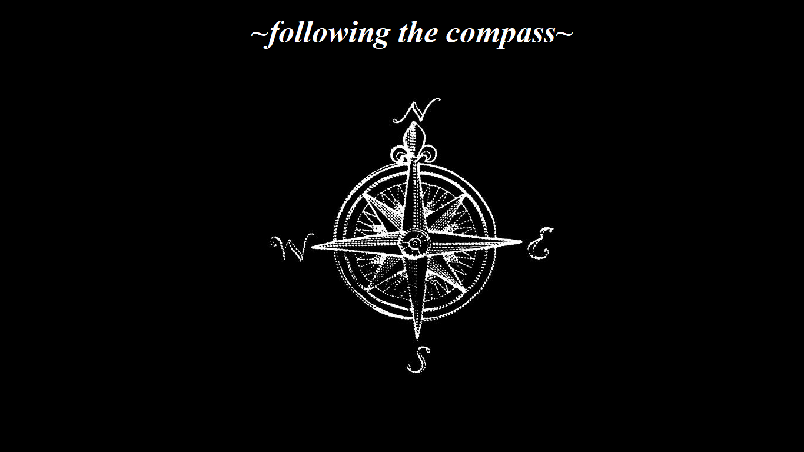

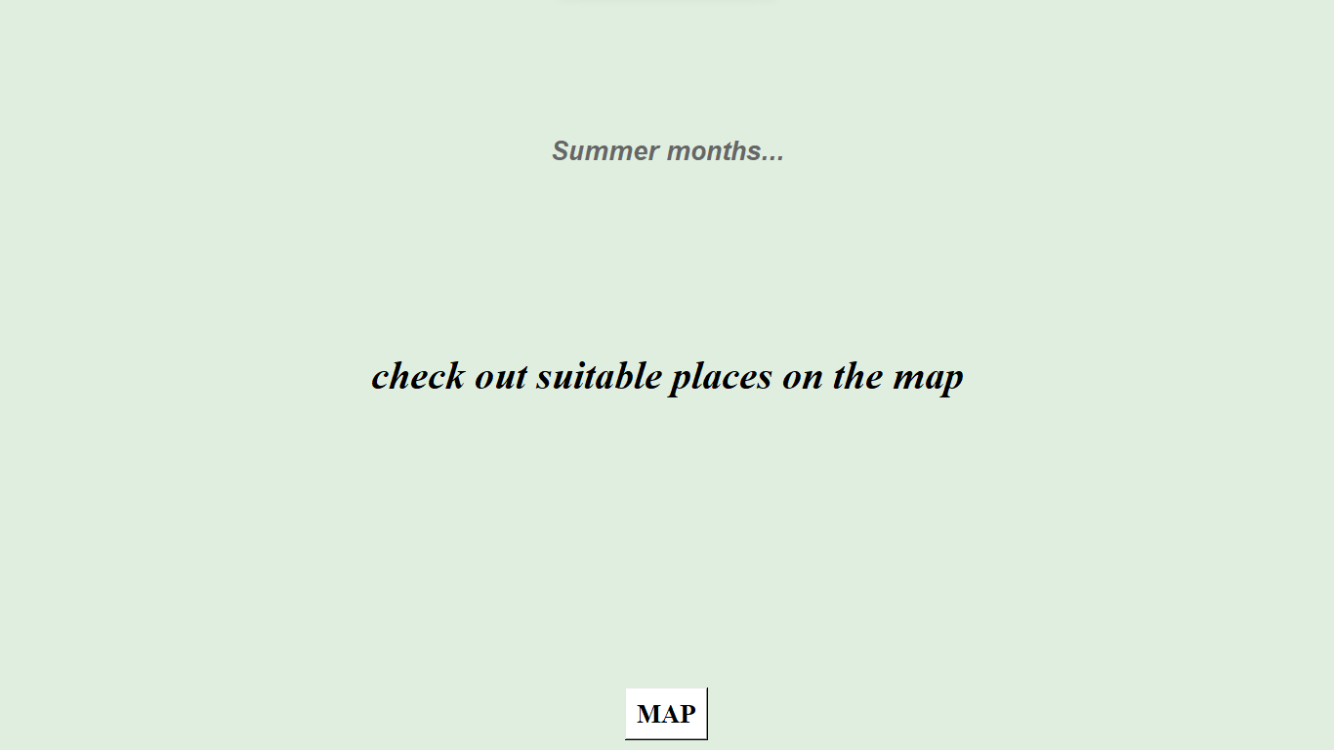

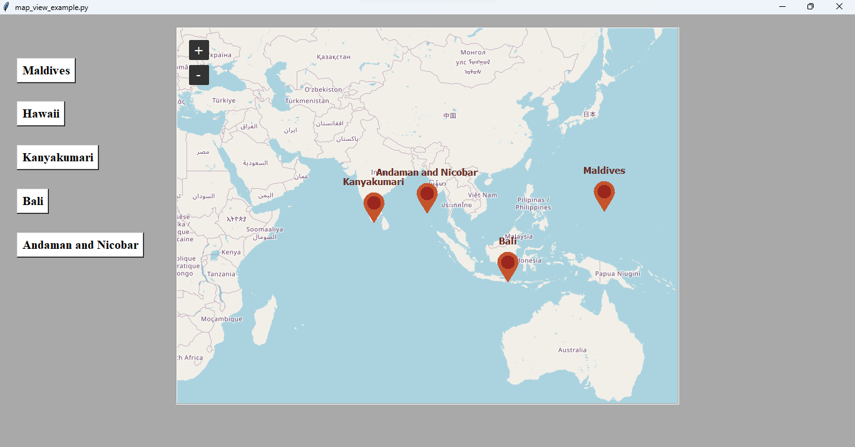

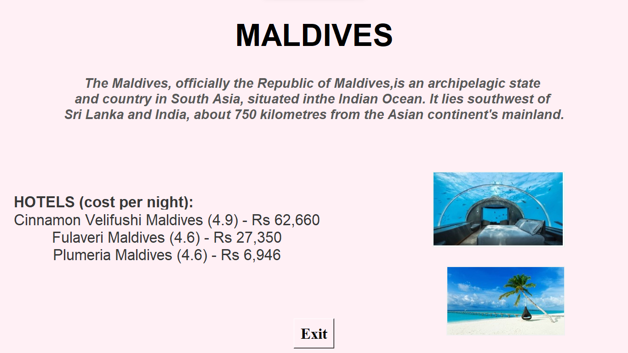

FUTURE SCOPE

The following enhancements can be easily added, to make this software even more useful:
- Give at least 5 enhancements in numbered format.

REFERENCES

- https://realpython.com/python-gui-tkinter/
- Geeksforgeeks
- (atleast 5)

